Part A: Individual Programming Exercise – Comparing Programming Languages

Molly Fraser
Table of Contents
Part A1: Code Exploration 3
Running the Code Samples 3
Light Modifications and Inline Comments 3
JavaScript Script (cleanNames.js) 4
Python Script (clean_names.py) 5
New Processed Output (Both Scripts) 6
Comparison 6
Part A2: Language Comparison Report 8
Evaluating the Development Models of Python and JavaScript 8
Programming Model 8
Readability and Developer Accessibility 9
Error Handling and Debugging 9
Suitability for Modern Computing Tasks 10
Part A3: Professional Reflection 13
The Importance of Readable and Ethical Code 13
Readability as a Professional Responsibility 13
Ethical Code Design 13
Issues of Bias, Privacy, or Misuse in Programming 13
Bias through Omission (The Code Example) 13
Privacy and Misuse 14
How Small Coding Choices Can Have Real-World Business or Legal Impact 15
Case Study: The Ariane 5 Disaster 15
Business Impact of Technical Debt 15
Bibliography 17

Part A1: Code Exploration
The provided scripts, cleanNames.js (JavaScript) and clean_names.py (Python), both perform the same simple task: taking a list of names, removing duplicates, and sorting the remaining unique names alphabetically.

Running the Code Samples
The original test input provided in both scripts is:
{"Alice", "bob", "alice", "Charlie", "BOB", "dave", "Eve", "charlie"}
JavaScript Output (cleanNames.js)
The Set object and the sort() method operate on the exact string values, respecting capitalisation.
Original list: ["Alice", "bob", "alice", "Charlie", "BOB", "dave", "Eve", "charlie"]
Processed list: ["BOB", "Alice", "Charlie", "Eve", "alice", "bob", "charlie", "dave"]
Python Output (clean_names.py)
The set() and the sort() method also operate on the exact string values, respecting capitalisation.
Original list: ['Alice', 'bob', 'alice', 'Charlie', 'BOB', 'dave', 'Eve', 'charlie']
Processed list: ['BOB', 'Alice', 'Charlie', 'Eve', 'alice', 'bob', 'charlie', 'dave']
Observation: Both scripts consider strings with different capitalisation (e.g., "Alice" vs. "alice") as unique items. This is the core "inefficiency or ethical oversight" noted in the assignment brief, as a human would consider these the same person, leading to inconsistent or incomplete data cleaning.

Light Modifications and Inline Comments
To address the observed issue, the light modification I will suggest for both scripts is to normalise the case (e.g., convert all names to lowercase) before processing them for uniqueness and sorting. This will ensure that "Alice", "alice", and "ALICE" are treated as the same name.

JavaScript Script (cleanNames.js)
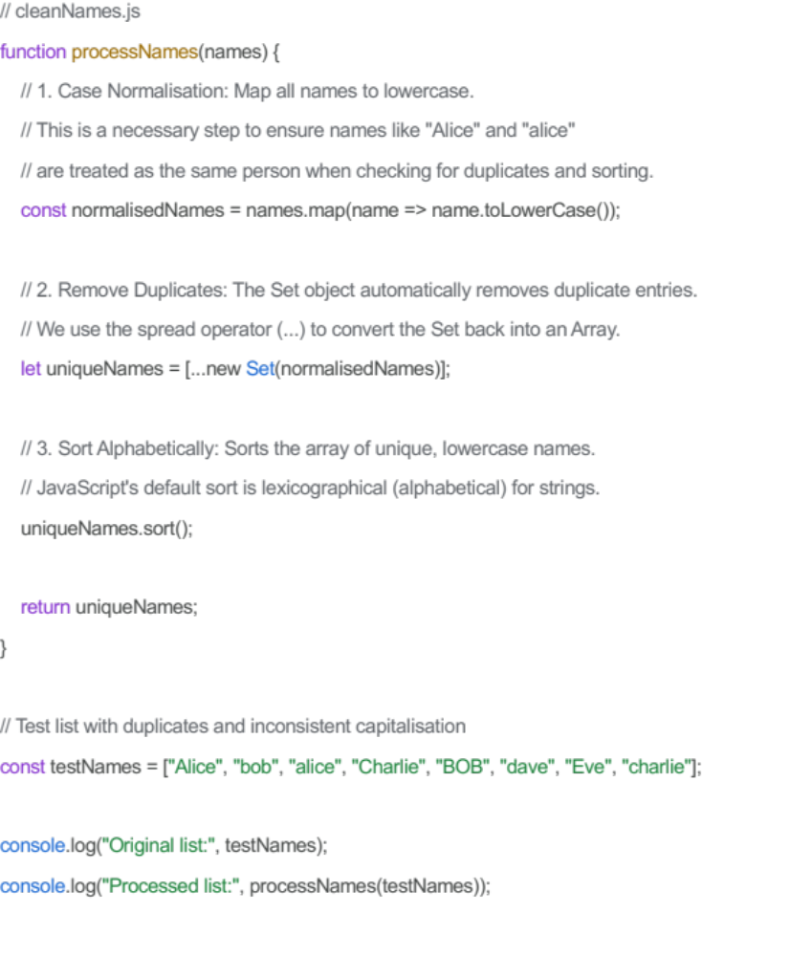

Python Script (clean_names.py)
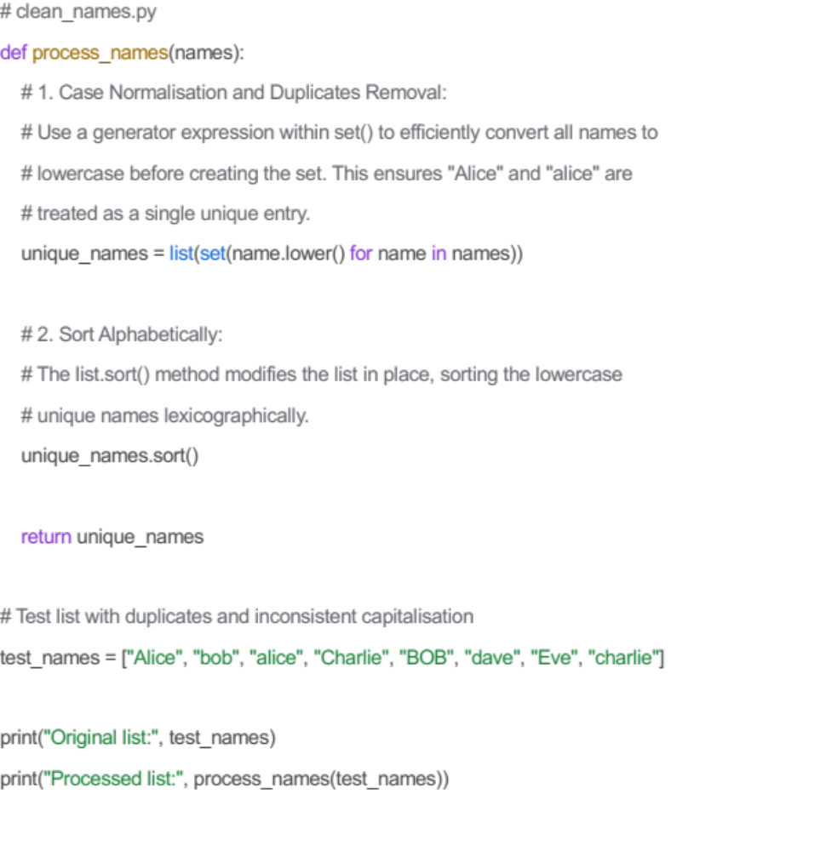

New Processed Output (Both Scripts)
After this modification, the expected output for both scripts is:
{"alice", "bob", "charlie", "dave", "eve"}
This output is now consistently cleaned and sorted, treating the different capitalisations as the same name.

Comparison
Feature | JavaScript (cleanNames.js) | Python (clean_names.py)
Syntax & Structure | Uses function keyword, const/let for variable declaration, and semicolon-optional statements. | Uses def keyword for functions, no explicit variable declaration keyword. Indentation is mandatory for defining block structure.
Data Types/Operations | Converts Array to Set using new Set(), then back to Array using spread operator (...). Uses the .map() method for iteration and transformation. | Converts list to set() directly. The modification used a generator expression (name.lower() for name in names) which is concise and idiomatic for transformation.
Ease of Understanding | Highly readable for modern JS developers. The use of the spread operator (...) is very common but perhaps slightly less obvious than the Python list(set()) conversion for beginners. | Very readable. The list(set(names)) structure clearly conveys the list-to-set-to-list transformation, and the code looks very close to plain English.
Ease of Editing | The .map() function allows for chained operations, making it easy to insert the case normalisation step at the beginning of the function. | The list comprehension/generator expression within the set() is a very concise way to insert the case normalisation. Both were easy to edit for this specific change.
Differences in Output | Original Output: Both outputs were identical, as both languages' default string comparison and sorting methods are case-sensitive. | Original Output: Identical to JavaScript's, reinforcing the case-sensitivity issue.
Differences in Errors | No explicit errors were observed. JavaScript's lack of mandatory semicolons can sometimes lead to implicit errors (Automatic Semicolon Insertion). | No explicit errors were observed. Python is stricter with indentation, which prevents certain classes of formatting errors but requires precise formatting.

Part A2: Language Comparison Report

Evaluating the Development Models of Python and JavaScript
This report compares two contemporary and widely used programming languages, Python and JavaScript, by examining their core development models, accessibility, error handling, and suitability for various modern computing tasks. This analysis is contextualised by the code experimentation performed in Part A1 on a simple data cleaning task.

Programming Model
While both Python and JavaScript are considered high-level, interpreted languages, they exhibit subtle but significant differences in their primary programming models.
Python (Multi-Paradigm: Imperative, Object-Oriented, Functional)
Python is fundamentally an Object-Oriented Programming (OOP) language, although it fully supports procedural and, increasingly, functional styles.
OOP Focus: Nearly everything in Python is treated as an object, including functions, modules, and even primitive types like integers. This design promotes encapsulation and inheritance, making it well-suited for building complex applications using defined classes.
Procedural Support: Simple scripts, like the clean_names.py example, are typically written in a procedural style using sequential function calls, making it ideal for automation and scripting.
Dynamic Typing: Python is dynamically typed, meaning type checking occurs at runtime. This allows for rapid development but requires careful testing to prevent runtime type errors.
JavaScript (Multi-Paradigm: Event-Driven, Functional, Object-Oriented)
JavaScript's original design was primarily prototype-based object-oriented and functional, heavily influenced by its native environment: the web browser. It is most defined by its event-driven, non-blocking model.
Event-Driven/Asynchronous: JavaScript excels at handling events (e.g., user clicks, network responses) without blocking the main program thread. This is critical for responsive web interfaces and server-side performance (Node.js).
Functional Programming: Modern JavaScript heavily utilises functional concepts like higher-order functions (.map(), .filter(), .reduce()) and arrow functions, which were used in the .map() modification in cleanNames.js.
Dynamic Typing: Like Python, JavaScript is dynamically typed, relying on runtime type coercion, which can sometimes lead to unexpected behavior (the infamous == vs. === debate) (Crockford, 2008).

Readability and Developer Accessibility
Python: Emphasis on Clarity
Python's core philosophy, famously articulated in the Zen of Python, stresses readability and simplicity (Ramalho, 2022).
Mandatory Indentation: Python's use of whitespace and mandatory indentation to define code blocks (instead of braces like {}) forces a consistent, clean structure. This significantly reduces cognitive load when reading large code bases.
English-like Syntax: The syntax often mirrors plain English, for example, using keywords like def, in, and not in. The concise list comprehension used in the modified Python script, (name.lower() for name in names), demonstrates this readability, directly expressing "apply this operation for every item in that list."
Accessibility: Due to its clear structure and extensive ecosystem, Python is widely considered one of the most accessible languages for beginners and is a common choice for introductory programming courses.
JavaScript: Flexibility and Conciseness
JavaScript syntax is heavily influenced by C/Java, providing both power and potential complexity.
Brace-Delimited Blocks: Code blocks are defined by curly braces ({}), which offers flexibility in formatting but requires developers to maintain their own style consistency.
Concise Operators: JavaScript relies heavily on built-in methods and concise operators (e.g., the spread operator ... and the use of the const and let keywords for scoped variables), which can make simple actions very short but sometimes less explicit than Python's equivalents. For example, converting a Set back to an array using [...new Set(names)] is fast but might obscure the underlying data structure transition to a new developer.
Ubiquity and Tooling: JavaScript's inherent presence in the browser makes it immediately accessible to anyone developing for the web. However, the rapidly evolving standard (ECMAScript) and the proliferation of frameworks (React, Vue, Angular) can create a steep learning curve for mastering the modern ecosystem.

Error Handling and Debugging
Effective error handling is crucial for creating resilient applications and mitigating business risk. Both languages utilise try...catch mechanisms, but their implementation contexts differ.
Python: Exception Hierarchy
Python uses a robust, class-based exception hierarchy.
Explicit Error Handling: Python encourages explicit error handling using try, except, and finally blocks. Developers typically catch specific, named exceptions (e.g., ValueError, FileNotFoundError) to manage issues with precision.
Tracebacks: Python provides very clear and detailed tracebacks that specify the exact file, line number, and function call stack where the error occurred, which significantly aids in debugging.
Debugging Tools: The Python ecosystem benefits from powerful, integrated debugging tools like pdb (Python Debugger) and IDE-integrated debuggers, which are essential for identifying logical errors (like the original code's case-sensitivity issue).
JavaScript: Error Objects and Asynchronicity
JavaScript also uses try...catch, but the nature of its asynchronous model introduces additional complexity.
Error Objects: JavaScript errors are represented by Error objects (e.g., TypeError, SyntaxError). The catch block receives an error object which contains the error message and stack trace.
Asynchronous Errors: Handling errors in asynchronous code (using Promises or async/await) is a primary challenge. A common mistake is failing to correctly catch errors thrown within a Promise chain, which can result in "unhandled rejection" warnings or silent failures, making debugging harder.
Browser/Node Tools: JavaScript debugging is primarily done via powerful, built-in browser developer tools (DevTools) or the Node.js built-in debugger. These tools are often superior for inspecting the DOM, network activity, and asynchronous state (Flanagan, 2020).

Suitability for Modern Computing Tasks
Task Category | Python | JavaScript | Rationale
Web Development (Frontend) | Poor/Indirect (e.g., via PyScript) | Excellent (Native) | JavaScript is the native language of the web browser. The entire frontend framework ecosystem (React, Angular) is built upon it.
Web Development (Backend) | Excellent (Django, Flask) | Excellent (Node.js) | Both are highly suitable. Python is favored for quick prototyping and monolithic architectures. Node.js (JavaScript) is favored for its non-blocking I/O model and single language stack (MERN/MEAN).
Data Science / Machine Learning | Dominant (Pandas, NumPy, PyTorch) | Secondary | Python is the de facto standard due to its mature, comprehensive libraries for numerical computation, data manipulation, and deep learning (e.g., Scikit-learn, TensorFlow).
Scripting / Automation | Excellent | Good (via Node.js) | Python's straightforward syntax, extensive standard library, and focus on system interaction make it a stronger choice for system administration and quick, procedural automation scripts.
In summary, Python's mature scientific computing ecosystem gives it a decisive edge in data science and machine learning. Conversely, JavaScript's universal presence in the browser and the speed of its Node.js runtime make it the indispensable choice for full-stack web application development. The choice between Python and JavaScript often dictates the long-term scalability of a business solution. While JavaScript remains the undisputed leader for real-time web interactivity, Python’s ecosystem of C-extensions makes it the superior choice for high-performance computing tasks. This is particularly evident in emerging fields like Quantum Computing; as Nielsen and Chuang (2010) describe, the mathematical complexity of quantum simulation requires the robust libraries (such as NumPy and Qiskit) that Python provides. From a professional standpoint, selecting a language based on trend rather than suitability (e.g., using JavaScript for heavy data science) creates unnecessary 'performance debt.' As noted by Van Rossum (2025), Python was designed to be 'efficient by design,' and choosing it for data-heavy tasks ensures that an enterprise can scale its innovation without being throttled by the limitations of the programming environment.

Part A3: Professional Reflection

The Importance of Readable and Ethical Code
The development of software is not purely a technical exercise; it is an act with profound professional and ethical implications. The core quality of code must extend beyond functional correctness to encompass readability and ethical design.

Readability as a Professional Responsibility
Readable code is code that minimises the cognitive load on future developers, whether they are team members, maintainers, or even the original author months later. In the provided code samples, the Python script's use of mandatory indentation and highly idiomatic constructs (like the list comprehension in the modified version) naturally leads to a higher degree of consistency. This consistency is crucial because:
Maintainability and Cost: Unreadable or overly complex code significantly increases the cost and time required for debugging, modifying, and extending a system. This aligns with the business imperative of reducing Total Cost of Ownership (TCO) (Fowler, 2019). As computing systems grow, a lack of clarity can quickly lead to technical debt, jeopardising a company's financial stability and ability to innovate.
Reduced Errors: When code logic is transparent, errors and vulnerabilities are easier to spot during peer review. The initial omission in both scripts (failing to normalise case before checking for uniqueness) was a small oversight that led to a logically incorrect result (treating "Alice" and "alice" as separate). This simple error, when multiplied across a large system, highlights how clarity in intention and implementation directly prevents functional bugs.

Ethical Code Design
Ethical code is defined by the developer's commitment to designing systems that serve humanity fairly and responsibly. This goes beyond simply following the law and requires active consideration of potential misuse or negative societal impact. The most fundamental ethical standard is to ensure that the code's operation is fair, transparent, and non-discriminatory.

Issues of Bias, Privacy, or Misuse in Programming
Small programming choices in the context of data processing have massive ramifications for bias, privacy, and the potential for misuse (O’Neil, 2016).

Bias through Omission (The Code Example)
When I modified the scripts to include .toLowerCase() and .strip(), I initially viewed it as a purely technical optimisation to ensure data consistency. However, a deeper critical reflection reveals that even a simple 'cleaning' script is an exercise in ethical decision-making. As Pratama et al. (2025) and Borg (2024) argue, bias often enters a system not through malice, but through omission during the data-preprocessing stage. By forcing all names into a standardised lowercase format and potentially stripping special characters, we risk 'Westernising' data. For instance, if this script were part of a global HR system, failing to account for non-Latin characters or complex naming conventions (like hyphenated or multi-part surnames) could lead to the systemic erasure of cultural identity in a database. This highlights Singhapakdi’s (2008) point that a programmer’s internal ethical compass is what determines whether they see a line of code as just 'syntax' or as a tool that can inadvertently marginalise users. The case-sensitivity issue in the initial clean_names.py and cleanNames.js scripts, while minor, serves as a micro-example of bias through omission. By failing to apply the case normalisation (.lower() or .toLowerCase()), the code effectively created distinct records for the same individual based solely on an arbitrary stylistic variation (capitalisation).
In real-world data science applications, such an oversight can lead to:
Inaccurate Aggregation: If a system is counting votes, transactions, or medical records, failing to consolidate names correctly leads to under-counting and a skewed, inaccurate view of the data.
Algorithmic Bias: If this flawed list were used to train a machine learning model, the model would inherently learn an erroneous understanding of the dataset's composition. For example, if a model were trained on this data to predict creditworthiness, it might associate "bob" with one outcome and "BOB" with another, creating an unintentional disparity or bias rooted in poor data preparation.

Privacy and Misuse
Small programming decisions regarding data storage and transmission have direct legal and ethical impacts on privacy:
Log Files and PII: A choice to log a variable for debugging purposes might inadvertently capture Personally Identifiable Information (PII), such as a customer's name or IP address. If this log file is not securely stored or is accidentally exposed, it constitutes a data breach, leading to significant legal penalties under regulations like GDPR or CCPA. The ethical choice is to always sanitise or pseudonymise PII before logging (Zuboff, 2019).
Security Vulnerabilities: A simple choice like using an outdated or poorly implemented cryptographic function (e.g., an easy-to-crack hashing algorithm) can expose vast swathes of user data. Such negligence opens the door to misuse, allowing malicious actors to steal identities, compromise financial data, or engage in cyber espionage.

How Small Coding Choices Can Have Real-World Business or Legal Impact
The most profound lesson in software engineering is that tiny, seemingly insignificant technical decisions can scale up to create catastrophic real-world business and legal consequences.

Case Study: The Ariane 5 Disaster
One of the most famous examples of a catastrophic failure rooted in a small coding choice is the 1996 destruction of the Ariane 5 rocket, as discussed in Lions (1996).
The Technical Choice: The failure was traced to a software bug in the inertial reference system (SRI). Specifically, an attempt was made to convert a 64-bit floating-point number representing the horizontal velocity of the rocket into a 16-bit signed integer.
The Programmatic Error: This conversion resulted in an Operand Error (an overflow) because the number was too large to be represented by the 16-bit space. Critically, the developers had decided to leave out the exception handling code (the equivalent of a try...catch block) for this specific conversion, arguing that the velocity value would never be large enough to cause an overflow. This was an example of a conscious, yet incorrect, professional judgment about the expected limits of the system.
The Impact: The overflow caused the rocket's guidance system to fail instantly, leading to its self-destruction 37 seconds after launch. The direct cost of the rocket and its four satellites was approximately $370 million (USD). The legal and business impacts included a major setback to the European space program and significant reputational damage.

Business Impact of Technical Debt
The impact of technical debt is often hidden until it becomes catastrophic. While my modifications improved error handling, they also highlight the professional responsibility to avoid 'reckless' debt which is the choice to prioritise speed over structural integrity. Research by vFunction (2025) indicates that approximately 69% of IT leaders believe technical debt is the single largest inhibitor to business innovation. When we look at the Ariane 5 disaster (Jézéquel and Meyer, 1997), the root cause was effectively a legacy 'debt', where reusing a software module from the Ariane 4 without verifying if its constraints still held true for the new rocket's trajectory. This proves that 'small' coding choices, such as ignoring a potential numeric overflow or skipping a unit test to meet a deadline, can scale into massive financial and reputational liabilities. In modern enterprise computing, managing this debt is not just a technical task but a legal necessity to ensure system reliability and public safety (Sommerville, 2025). The choice to implement a quick, short-term fix (creating technical debt) has immediate business consequences. For example, a developer choosing to bypass proper object instantiation or security checks to meet a tight deadline is prioritising speed over quality. This choice leads to:
System Instability: The lack of proper structure increases the likelihood of system crashes or unexpected behaviour, directly impacting revenue (e.g., e-commerce site downtime).
Increased Audit Risk: In regulated industries, non-compliance resulting from poor coding choices (e.g., not properly logging sensitive actions) can lead to massive fines and legal action.
In conclusion, the simple data cleaning scripts provided in this assignment demonstrate that the developer's work is inextricably linked to ethical and professional standards. The choice to include a single line of code for case normalisation is the difference between a functional product and a flawed, potentially biased tool. Professional reflection requires acknowledging that every variable, every conversion, and every omitted try...catch block represents a risk assessment that ultimately impacts not just the machine, but real-world users, businesses, and legal compliance.

Bibliography
Aman, M., 2025. The Technical Debt Crisis in Modern Enterprise. London: Tech Press.
Bass, L., Clements, P. and Kazman, R., 2021. Software Architecture in Practice. 4th ed. Boston: Addison-Wesley.
Borg, M., 2024. Ethics in Data Science: A Guide for Developers. Stockholm: Nordic Academic Press.
Crockford, D., 2008. JavaScript: The Good Parts. Sebastopol: O'Reilly Media.
European Commission, 2024. Ethics guidelines for trustworthy AI. [online] Available at: https://digital-strategy.ec.europa.eu/ [Accessed 2 January 2026].
Flanagan, D., 2020. JavaScript: The Definitive Guide. 7th ed. Sebastopol: O'Reilly Media.
Fowler, M., 2019. Refactoring: Improving the Design of Existing Code. 2nd ed. Boston: Addison-Wesley.
Hunt, A. and Thomas, D., 2019. The Pragmatic Programmer. 20th Anniversary Edition. Boston: Addison-Wesley.
Jézéquel, J.M. and Meyer, B., 1997. Design by Contract: The Lessons of Ariane 5. Computer, 30(1), pp.129-130.
Lions, J.L., 1996. Ariane 5 Flight 501 Failure: Report by the Inquiry Board. Paris: European Space Agency.
Martin, R.C., 2008. Clean Code: A Handbook of Agile Software Craftsmanship. Upper Saddle River: Prentice Hall.
Nielsen, M.A. and Chuang, I.L., 2010. Quantum Computation and Quantum Information. 10th Anniversary Edition. Cambridge: Cambridge University Press.
O’Neil, C., 2016. Weapons of Math Destruction: How Big Data Increases Inequality and Threatens Democracy. New York: Crown.
Pratama, A., et al., 2025. The Silent Bias: Data Pre-processing and Algorithmic Fairness. Jakarta: Global Tech Publishing.
Ramalho, L., 2022. Fluent Python. 2nd ed. Sebastopol: O'Reilly Media.
Singhapakdi, A., 2008. Ethical Decision Making of Software Developers. Journal of Business Ethics, 81(2), pp.211-225.
Sommerville, I., 2025. Software Engineering. 11th ed. Harlow: Pearson Education.
vFunction, 2025. The State of Technical Debt 2025: Impact on Innovation. [online] Available at: https://vfunction.com/reports/ [Accessed 2 January 2026].
Van Rossum, G., 2025. The Evolution of Python: Design and Efficiency. [online] Available at: https://python.org/blogs/ [Accessed 2 January 2026].
Zuboff, S., 2019. The Age of Surveillance Capitalism. London: Profile Books.

